BELMONT CITY COLLEGE

YEAR 11 ATAR MODERN HISTORY SOURCE ANALYSIS – UNIT 1
SEMESTER ONE 2015

DOCUMENT BOOKLET

MODERN HISTORY SOURCE ANALYSIS
Date: 2015
Marks: 25 marks
12.5% of Semester Total

CONTENTS:

Document Set | Area of Study | Number of sources | Related questions
1 | Elective 5: The Age of Imperialism | 4 | 1 (5 parts)

DOCUMENT SET
THE AGE OF IMPERIALISM

Source 1
"Showing the Light to the Filipinos", Boston Herald, March 1899
From 1898 to 1902, the United States waged a bloody war in the Philippines. Filipinos wanted independence from centuries of Spanish colonial rule. U.S. leaders, however, saw the opportunity to control the Philippines and gain access to markets in Asia. President McKinley argued that the Filipinos could not govern themselves or defend themselves against other countries. Many supporters of the Philippine-American war also believed in the "civilizing mission"—the idea that European nations and the United States had a moral duty to civilize "backwards" peoples in other parts of the world by introducing Western culture and technology.

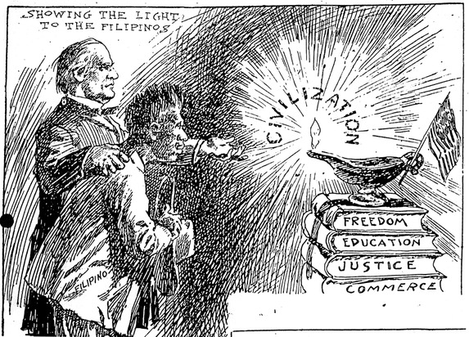

Source 2

"The White(?) Man's Burden"

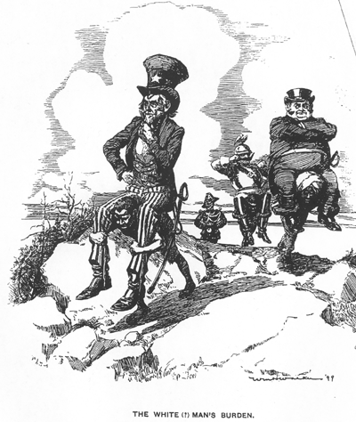

Satire of Kipling's phrase shows the "white" colonial powers being carried as the burden of their "coloured" subjects.
First printed in Life, March 16, 1899.

Source 3

Kaiser Wilhelm II of Germany: Speech to the North German Regatta Association, 1901 – Also called the “Place in the Sun Speech”

In spite of the fact that we have no such fleet as we should have, we have conquered for ourselves a place in the sun. It will now be my task to see to it that this place in the sun shall remain our undisputed possession, in order that the sun's rays may fall fruitfully upon our activity and trade in foreign parts, that our industry and agriculture may develop within the state and our sailing sports upon the water, for our future lies upon the water. The more Germans go out upon the waters, whether it be in races or regattas, whether it be in journeys across the ocean, or in the service of the battle flag, so much the better it will be for us.

Source:
C. Gauss, The German Kaiser as Shown in His Public Utterances (New York: Charles Scribner's Sons, 1915), pp. 181-183.
Background info:
(a regatta is a boat/yacht race)
Until their 1871 unification, the German states had not concentrated on the development of a navy, and this essentially had precluded German participation in earlier imperialist scrambles for remote colonial territory – the so-called "place in the sun". Germany seemed destined to play catch-up.
Source 4

Excerpt from John A. Hobson ‘Imperialism: A Study 1902’. John Hobson was an English economist who wrote one of the most famous critiques of the economic bases of imperialism in 1902.
So long as England held a virtual monopoly of the world markets for certain important classes of manufactured goods, Imperialism was unnecessary. After 1870 this manufacturing and trading supremacy was greatly impaired: other nations, especially Germany, the United States, and Belgium, advanced with great rapidity, and while they have not crushed or even stayed (halted) the increase of our external trade, their competition made it more and more difficult to dispose of the full surplus of our manufactures (goods) at a profit. The encroachments made by these nations upon our old markets, even in our own possessions, made it most urgent that we should take energetic means to secure new markets. These new markets had to lie in hitherto undeveloped countries, chiefly in the tropics, where vast populations lived capable of growing economic needs which our manufacturers and merchants could supply. Our rivals were seizing and annexing territories for similar purposes, and when they had annexed them closed them to our trade the diplomacy and the arms of Great Britain had to be used in order to compel the owners of the new markets to deal with us: and experience showed that the safest means of securing and developing such markets is by establishing 'protectorates' or by annexation.... It was this sudden demand for foreign markets for manufactures and for investments which was avowedly responsible for the adoption of Imperialism as a political policy....

END OF DOCUMENT SET
ACKNOWLEDGEMENTS

Document Set 1

Source 1 Unknown, “"Showing the Light to the Filipinos", Boston Herald, March 1899” HERB: Resources for Teachers, accessed December 4, 2014, http://www.herb.ashp.cuny.edu/items/show/655.
Source 2 Wm. H. Walker, "The White(?) Man's Burden." Illustration, Life 33, March 16, 1899.
Source 3 C. Gauss, The German Kaiser as Shown in His Public Utterances (New York: Charles Scribner's Sons, 1915), pp. 181-183.

Source 4 John A. Hobson, Imperialism: A Study 1902 (London: Allen and Unwin, 1948), pp.35. Retrieved from: Modern History Sourcebook: http://legacy.fordham.edu/halsall/mod/1902hobson.asp

